- What is the count of purchases per month (excluding refunded purchases)?
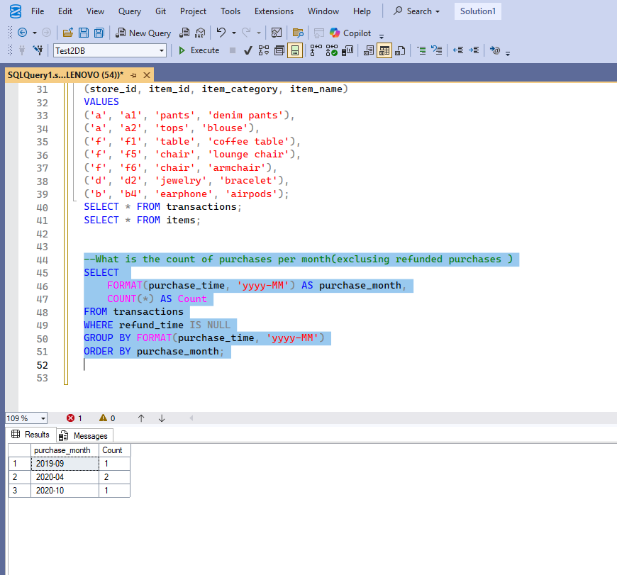

- . How many stores receive at least 5 orders/transactions in October 2020?
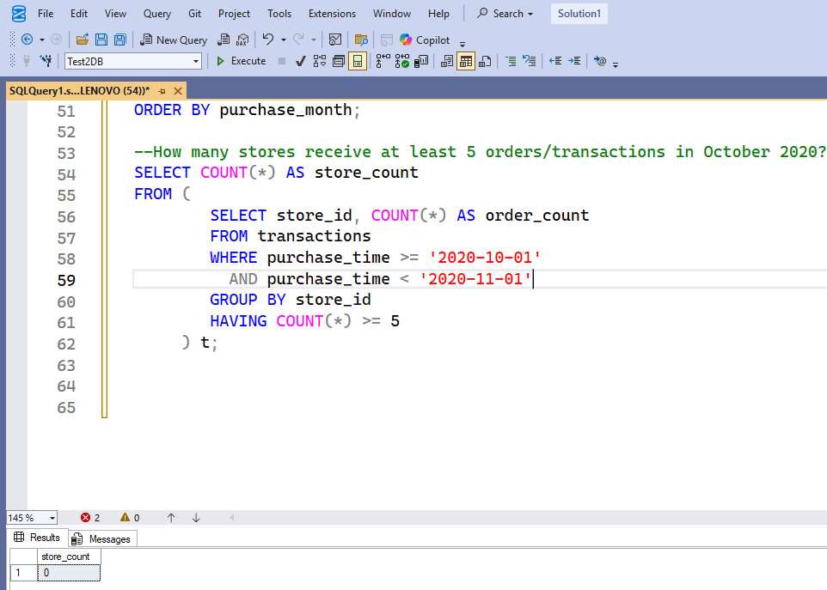

- For each store, what is the shortest interval (in min) from purchase to refund time?
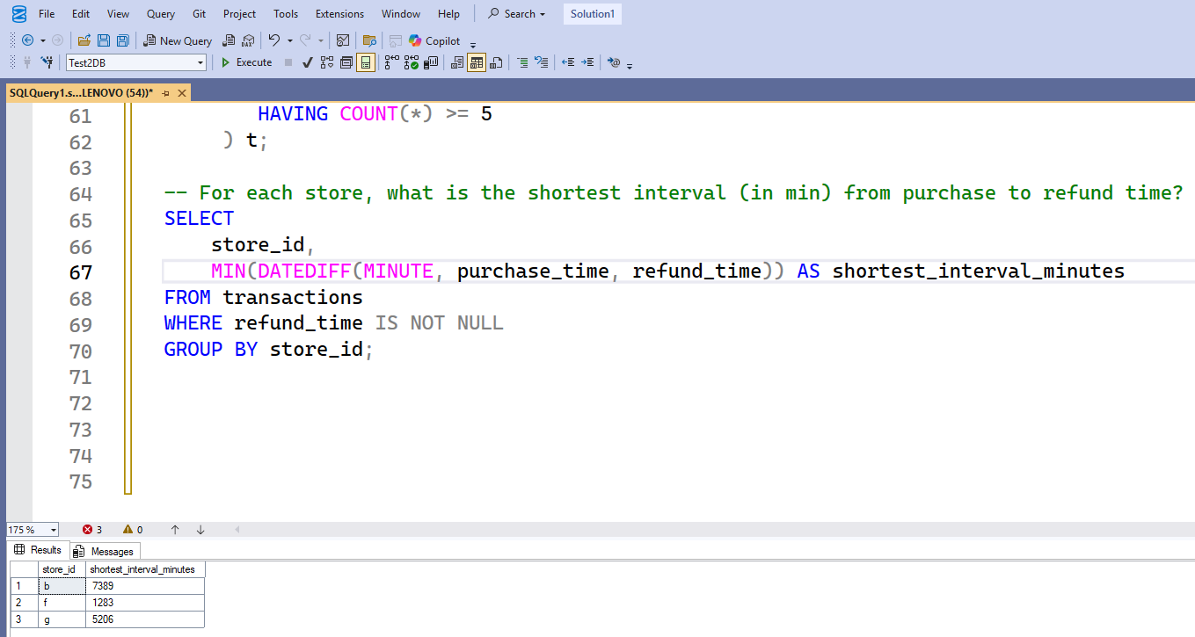

- What is the gross_transaction_value of every store’s first order?
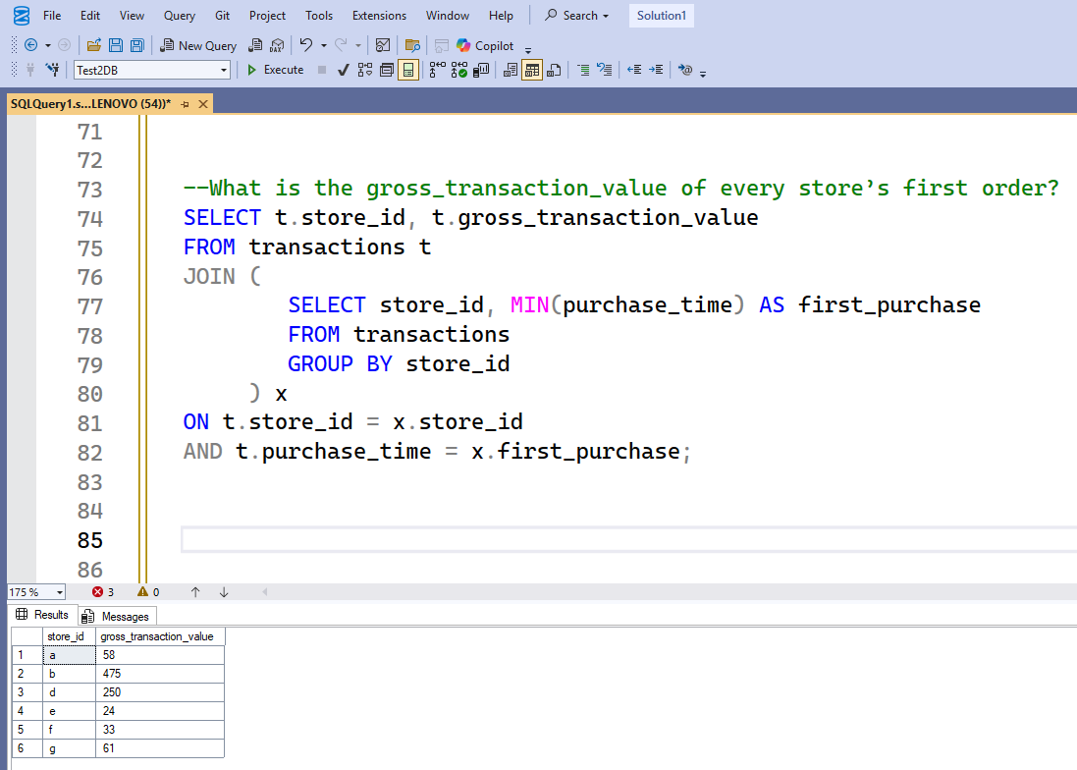

- What is the most popular item name that buyers order on their first purchase?
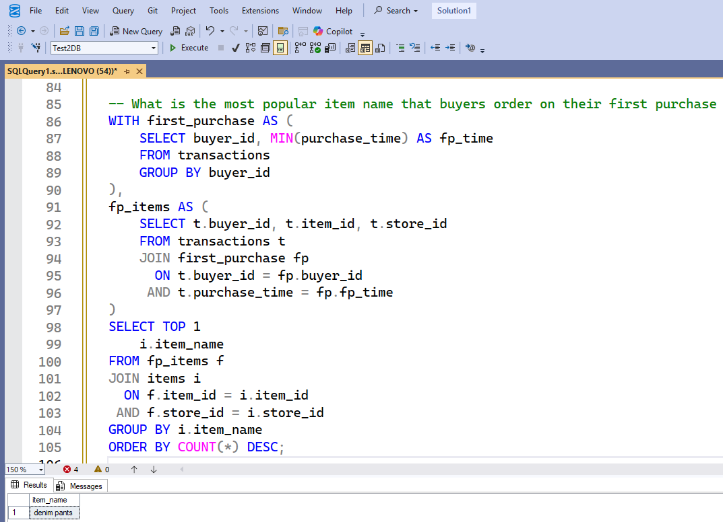

- Create a flag in the transaction items table indicating whether the refund can be processed or not.
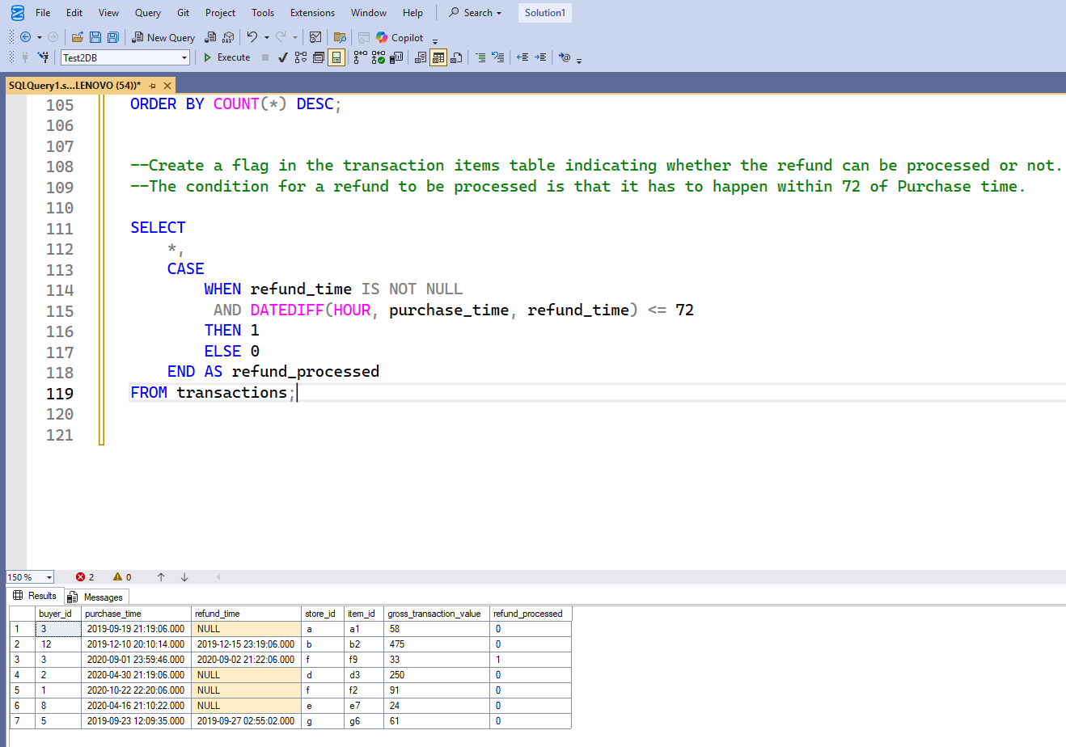
- Create a rank by buyer_id column in the transaction items table and filter for only the second purchase per buyer.
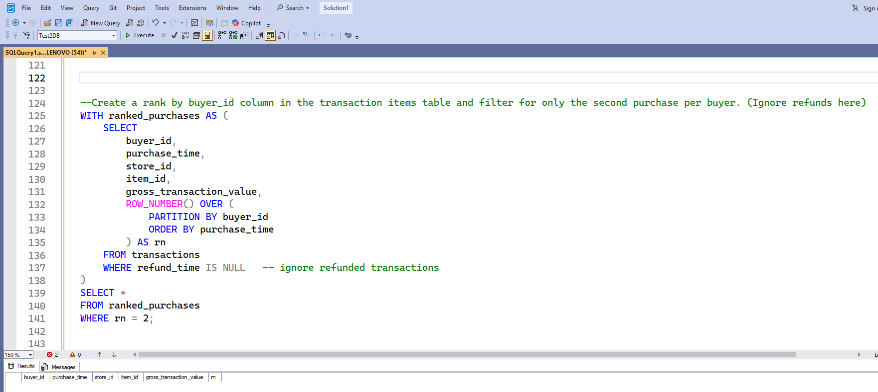

- How will you find the second transaction time per buyer

